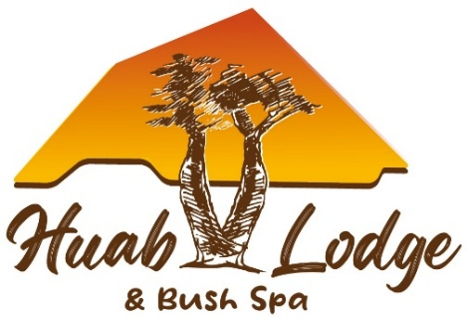
HUAB SAFARI RANCHES (Pty) Ltd
P. O. Box 69
Outjo
Namibia
Reservation Enquiries : huab@resdest.com
Tel. : 061 – 250 725
___________________________________________________________________________

HUAB LODGE Updated July 2026

Full-Day Ephemeral River Drive : tracking / searching for the Desert-Adapted Elephants
Experience one of Damaraland's most unforgettable wildlife adventures as you journey through the spectacular Huab River Valley in search of Namibia's remarkable desert-adapted elephants.
Your day begins with a well-balanced breakfast at 07:00, before departing the lodge at 07:30. Travelling along the sandy Huab Riverbed and its surrounding tributaries, your experienced guide and tracker will interpret fresh elephant tracks, turning the excursion into a genuine tracking adventure. Every safari is unique, as the elephants roam freely across this vast wilderness.
As you explore the dramatic landscapes of the Huab Valley, you'll discover a variety of wildlife, birdlife, and breathtaking scenery. If the elephants are located, you'll have the opportunity to observe these magnificent animals respectfully in their natural habitat while enjoying a memorable coffee stop surrounded by nature.
Between 10:00 and 11h00, you'll pause for freshly brewed coffee, tea or hot chocolate, accompanied by homemade rusks in a peaceful wilderness setting, sometimes with the elephants in the distance.
The journey continues with a visit to the wildlife water dam, build by Deon and his team in 2025, an important water source that supports many of the valley's animals throughout the year.
Between 12h00 and 13h00, you'll stop at the Onguwati Bar, where you can relax with a refreshing cold drink while your guide prepares a traditional Namibian braai (barbecue) lunch served with delicious side dishes at the Onguwati Bar or Caffee Anette.
After lunch, we drive back through the valley, arriving at Huab Lodge between 15:00 and 16h00.

Included in the fees
- Experienced guide, tracker and vehicle
- Traditional Namibian food for lunch
- Coffee, tea and homemade rusks
- Soft drinks and bottled water throughout the day
- Drinks at the Ongwati Bar
- Concession fees
Duration: Approximately 7 hours
Please note : As this is a true wildlife tracking experience, elephant sightings cannot be guaranteed, making every safari an authentic and exciting adventure.

Half-Day Rock Art & Historic Graves Excursion (THIS IS NOT AT TWYFELFONTEIN)
Step back in time and discover the rich cultural heritage of Damaraland on this fascinating journey through ancient landscapes shaped by thousands of years of history.
After breakfast at 07:30, depart the lodge at 08:00 and travel east through the striking scenery of Damaraland. During the approximately 45-minute drive, your guide will share insights into the unique geology, wildlife and history of the region.
Your destination is a remarkable collection of San (Bushman) rock engravings, created by some of Namibia's earliest inhabitants more than 2,000 years ago. A guided walk through the area reveals fascinating engravings and provides an opportunity to learn about the traditions, beliefs and daily lives of the San people.
Along the way, you'll also visit historic German graves, offering a glimpse into Namibia's colonial past and highlighting the diverse cultures that have shaped this extraordinary landscape.
Midway through the excursion, relax with a scenic coffee or tea break, accompanied by light snacks, before continuing your exploration.
The excursion returns to Huab Lodge at approximately 12:30, leaving plenty of time to enjoy lunch at the lodge and relax at the pool.

Included
- Experienced guide, tracker and vehicle
- Coffee, tea and light snacks
- Soft drinks and bottled water
- Cultural and historical interpretation by your guide
- Concession fees
Duration: Approximately 4½ hours

Discover the Spirit of Damaraland
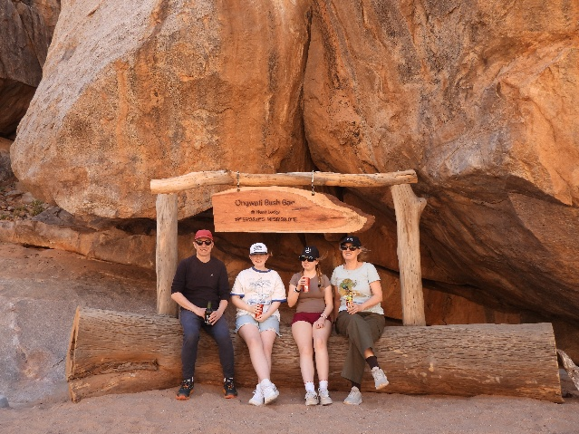
Whether you're tracking the legendary desert-adapted elephants through the Huab River Valley or exploring ancient San rock engravings and historic sites, these guided excursions offer unforgettable experiences that combine spectacular landscapes, fascinating history, exceptional wildlife, and the warm hospitality that makes Huab Lodge so special.
